Code

* Show All Code
* Hide All Code
* Download Rmd

### [Visualize a prediction model](https://github.com/VIS-SIG/Wonderful-Wednesdays/tree/master/data/2020/2020-12-09)

#### Agustin Calatroni

#### 12/26/2020

Instead of a table-based approach, the color-based method to present the score system of Residual Tumor. The color corresponding to each predictor value corresponds to a number of points, which is indicated within each colored interval. The patient’s score is the sum of the points for all predictors. This score is converted into a risk estimate by means of the last color bar where a dark green color indicates a low risk and a light green to ecru color indicates high risk. This visualization of the model allows users to instantly gauge which predictors contribute most to a high risk estimate.

Van Belle, Vanya, and Ben Van Calster [“Visualizing risk prediction models.”](https://journals.plos.org/plosone/article?id=10.1371/journal.pone.0132614) PloS one 10.7 (2015)

Overall Visualization

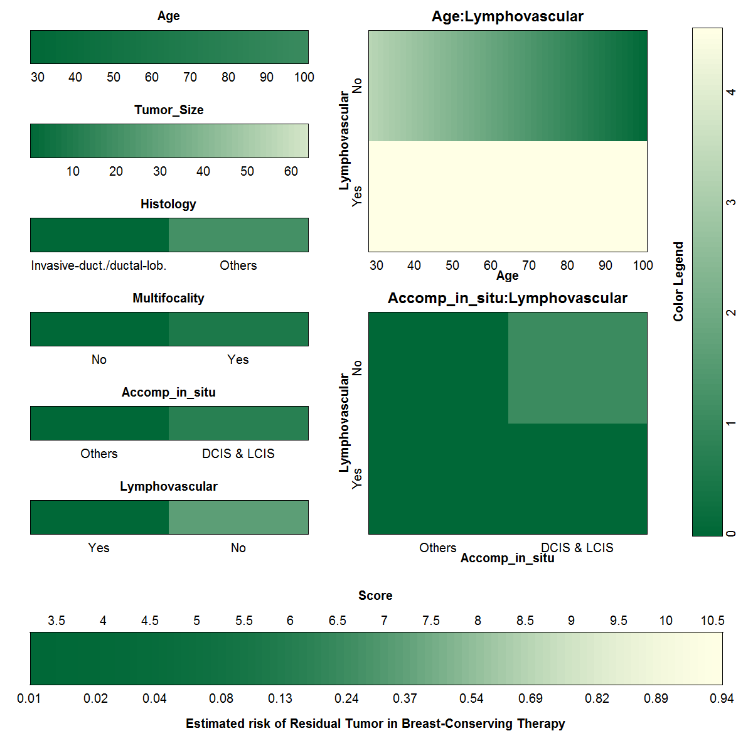

Individual Visualization (ID=140)

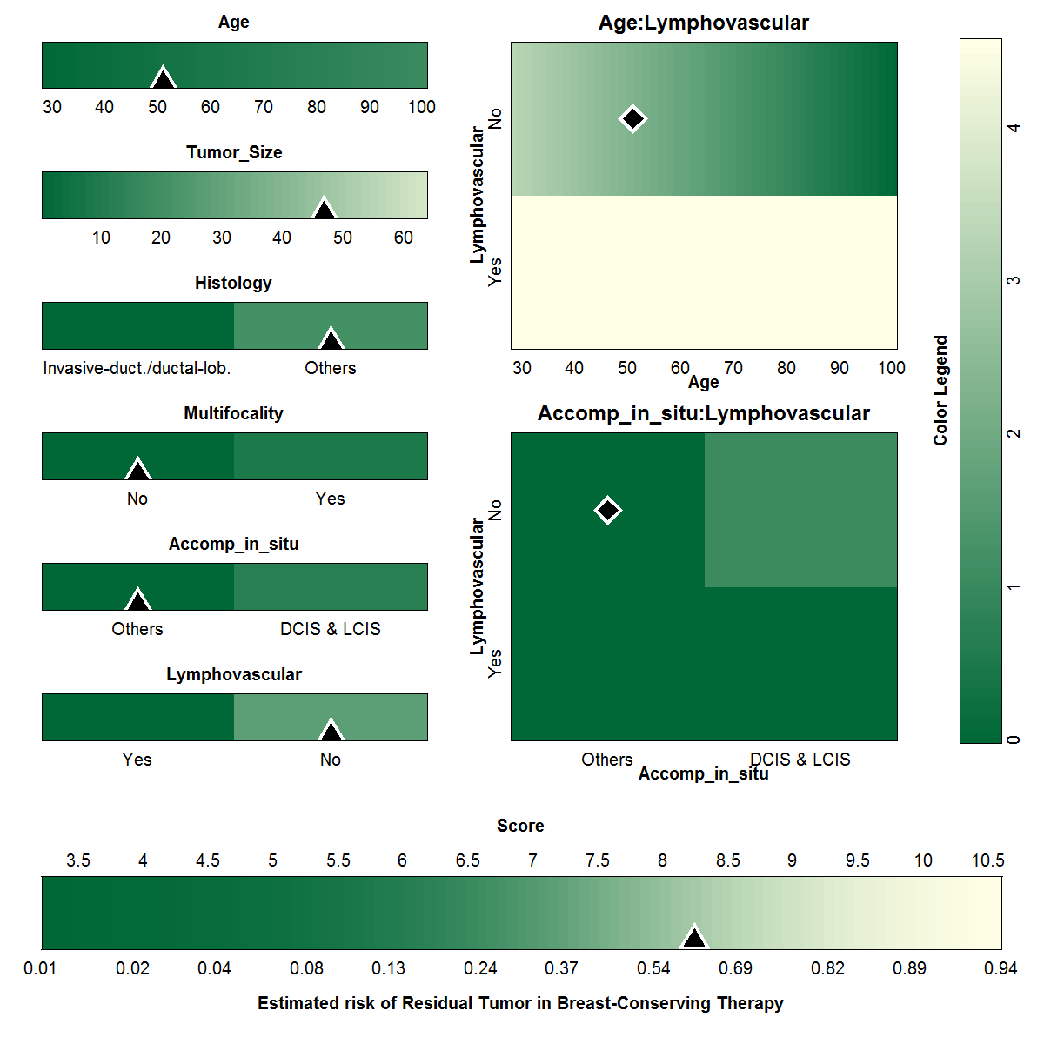

Prediction Model Logistic Regression w/ Interactions

|  |  |  |  |
| --- | --- | --- | --- |
| Characteristic | OR1 | 95% CI1 | p-value |
| Age | 1.01 | 0.97, 1.06 | 0.49 |
| Tumor_Size | 1.06 | 1.04, 1.08 | <0.001 |
| Histology |  |  |  |
| Invasive-duct./ductal-lob. | — | — |  |
| Others | 3.41 | 2.16, 5.46 | <0.001 |
| Multifocality |  |  |  |
| No | — | — |  |
| Yes | 1.65 | 0.95, 2.85 | 0.071 |
| Accomp_in_situ |  |  |  |
| Others | — | — |  |
| DCIS & LCIS | 2.06 | 0.59, 7.30 | 0.25 |
| Lymphovascular |  |  |  |
| Yes | — | — |  |
| No | 5.16 | 0.34, 82.7 | 0.24 |
| Age * Lymphovascular |  |  |  |
| Age * No | 0.96 | 0.91, 1.00 | 0.061 |
| Accomp_in_situ * Lymphovascular |  |  |  |
| DCIS & LCIS * No | 2.86 | 0.73, 11.3 | 0.13 |
| *1* OR = Odds Ratio, CI = Confidence Interval | | | |

